Interface document-web security detection

1. **current page**

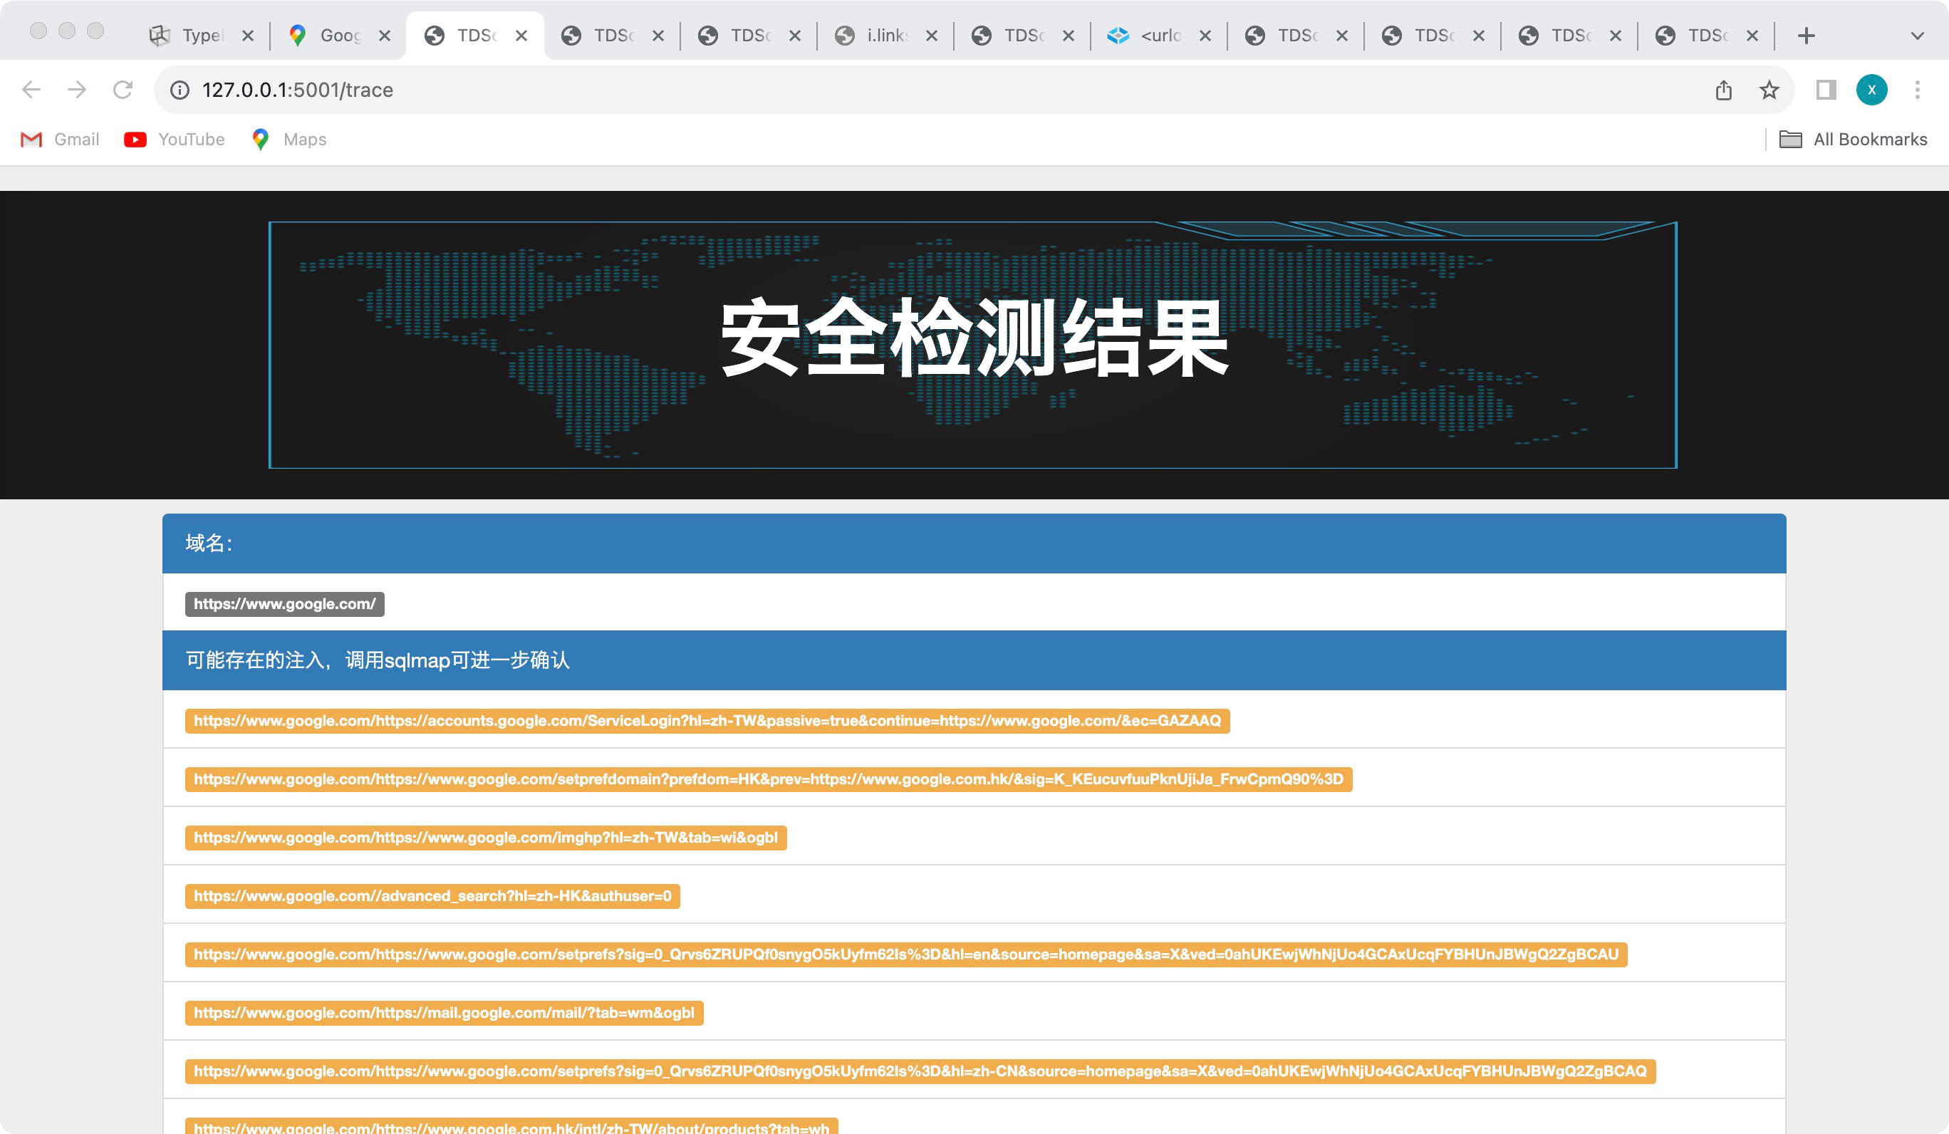

1. **Function list**

**Input:**

|  |  |  |  |
| --- | --- | --- | --- |
| name | type | request | example |
| target_url | string | maximum:varchar(50) | https://www.google.com/maps |

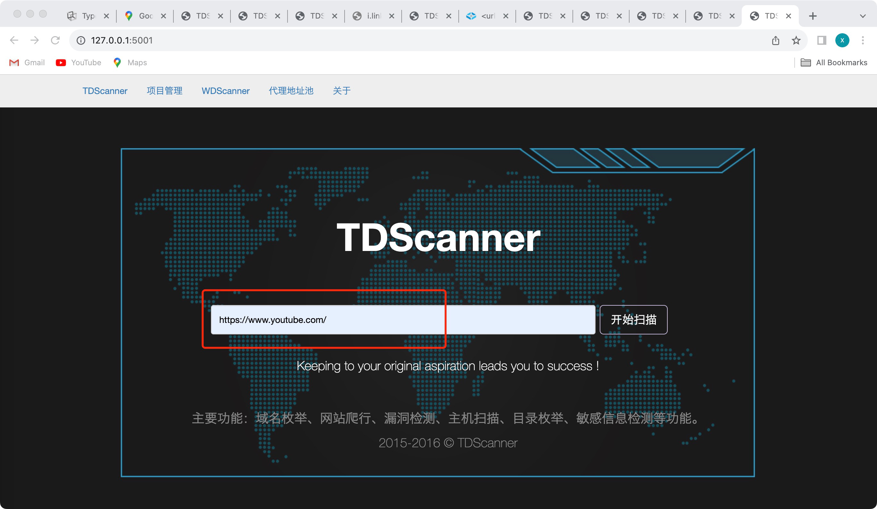

**Output:**

|  |  |  |  |
| --- | --- | --- | --- |
| function | type | name | example |
| sql injection | list | target_urllist | ['https://www.google.com/mapshttps://support.google.com/maps/?hl=zh-TW&authuser=0&p=no_javascript'] |
| Home page probe ip | list | iplist | ['19.144331.765317.5996321632', '3216.496431.977416.987531', '30.516616.541128.8215162716', '1827.467118.992729.702420', '1.9.0.4'] |
| Web directory blasting | list | collect_dirs |  |
| Common port detection | list | collect_ports | ['[-]21/tcp closed', '[-]22/tcp closed', '[-]23/tcp closed', '[-]25/tcp closed', '[-]53/tcp closed', '[-]80/tcp closed', '[-]389/tcp closed', '[-]8080/tcp closed', '[-]1433/tcp closed', '[-]2375/tcp closed', '[-]3389/tcp closed', '[-]6379/tcp closed', '[-]11211/tcp closed', '[-]27017/tcp closed'] |
| Subdomain burst |  | subdomain |  |